Project Title:
Android Tablet Note Application

Required Specializations (Skills required, and hardware/software required):
- Java
- Android Studio
- Galaxy Tab(for testing our application)
- GoodNote, Notability(application on iPad) to compare with our application
Project Statement: (max. 500 words) (Please state the main objectives of the project and its realistic constraints clearly, and the broadly final results, also ensure that the project is attainable in one semester)
There are many note apps on the iPad, but various note apps don’t exist on Android tablet. And the Android note app relatively lacks functionality. For user convenience, we need a note application for Android.
Through this application, it may be helpful to students who have used the uncomfortable note app so far.
Also, hopefully, we will contain functions that can share notes on my tablet to other people. This function will be helpful when we are doing group project and so on.
We may have constraints on file type that can download. Also, as we can’t do beta test, our applications’ UI can be little uncomfortable.
Our final output will be a combination of the advantages of the application the ‘GoodNote’(easy to converse documents) and ‘Notability’(has voice recording function) applications in iPad. It includes voice recording and document conversion and directory function. Of course our application will have functions that basic note application offer such as drawing, attaching pictures, changing pen color and boldness, opacity, texture and so on.

Furthermore, the features we mentioned earlier are all scattered in the iPad note application, not in one application.

Ensuring that the project is attainable in one semester
Week 3: Analyze and compare existing apps, make details of the features that will be on our application, study how to implement features
Week 4: study how to implement features, make github repository, make intermediate report, prepare presentation
Week 5: split up role by functions, implementation
Week 6: implementation
Week 7: implementation, make intermediate report
Week 8: merge our implementation
Week 9: make testing case, first testing, debug errors
Week 10: debug errors
Week 11: second testing
Week 12: debug errors
Week 13: Final testing for our application
Week 14: make final report, make presentation

Pre-requisites (if any)
No Pre-requisites

Number of Students (min. 4 students, max. 5 students): 4 Members
List of students:
Student ID | Student Name | Initial Project Role
2016313679 | Park Jinryeong | Team Leader, Programmer
2016312123 | Lee Gahyun | Tester, Programmer
2016314216 | Lee Sang Ah | UI Designer, Programmer
2016314718 | Lee Sung Jae | Debugger, Programmer

List of Software/ hardware intended to be used:
- Galaxy Tablet
- Android Ver. 10 (maybe)

3. Figures, resources, references, or extra explanations to the project idea (Free to include details as you want- unlimited pages)
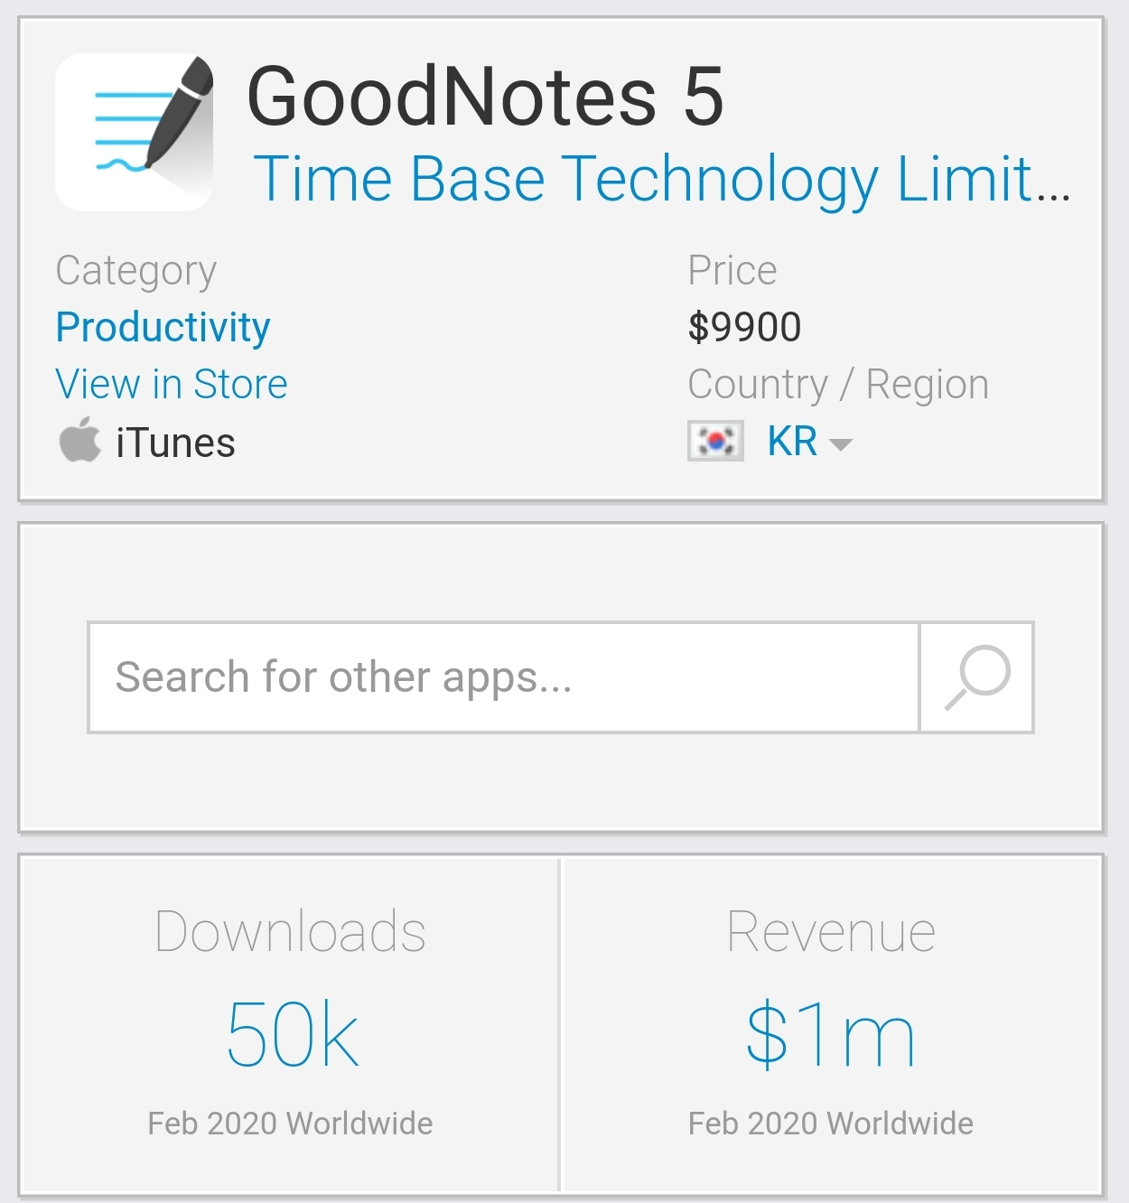
<picture of proving that many people are using Note application>

People using Tablet use the Note app a lot. In iPad, there are many note application that has many functions but Android doesn’t have any.
Our Android note application will make the function of the note app provided only on the iPad possible on the Android system.
Followings are the picture of key features of note app on iPad.

We will make this Android Note application by using Android studio.
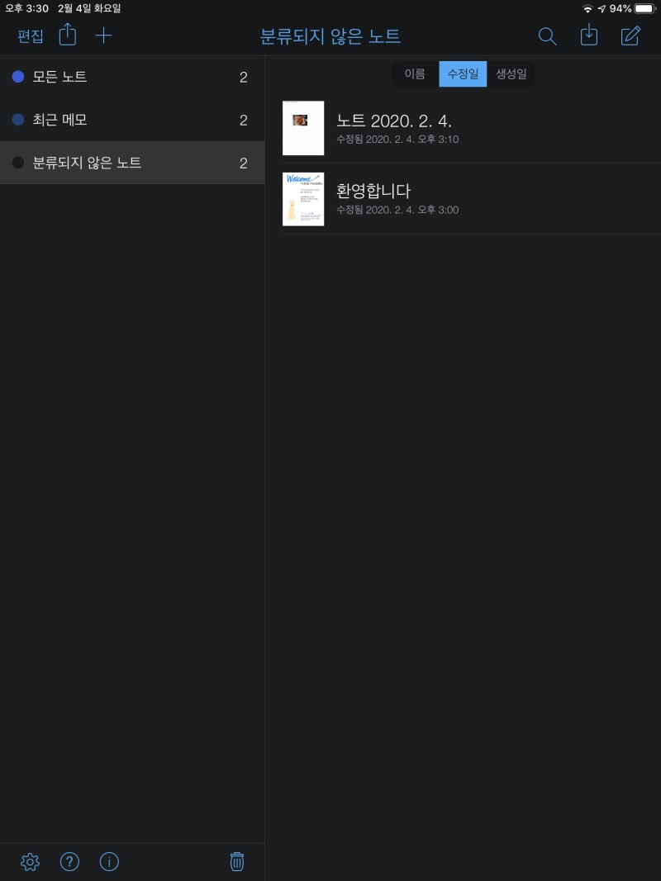
<picture of directory on ‘Notability’>
This directory function is helpful to recognize what this note is. Also we can categorize Notes
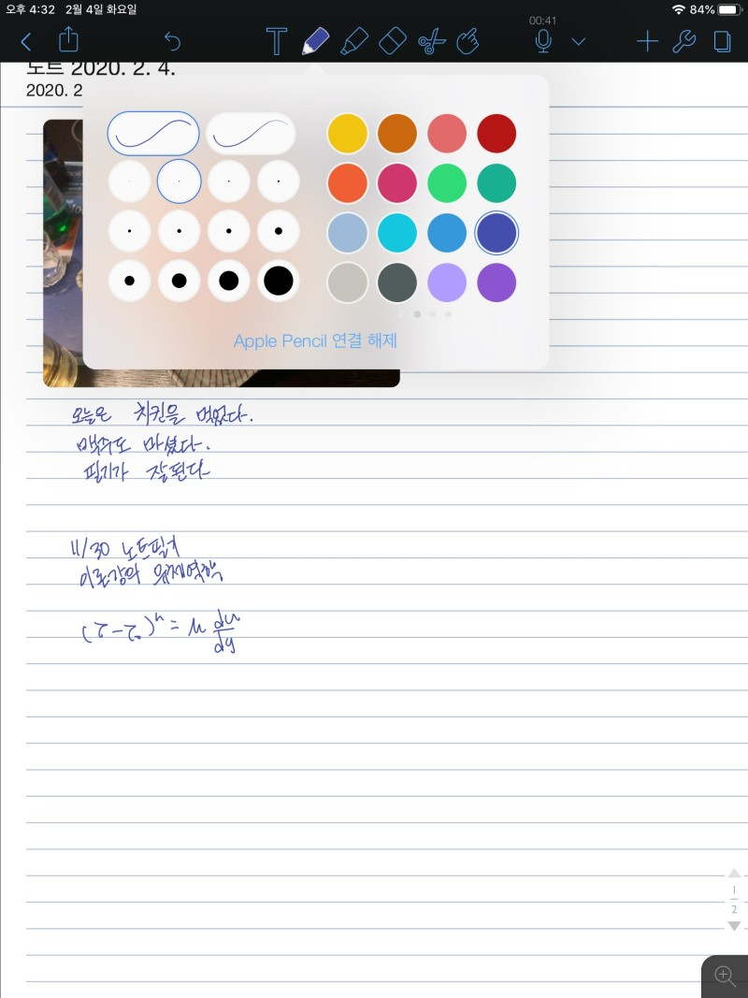
<picture of drawing on ‘Notability’>
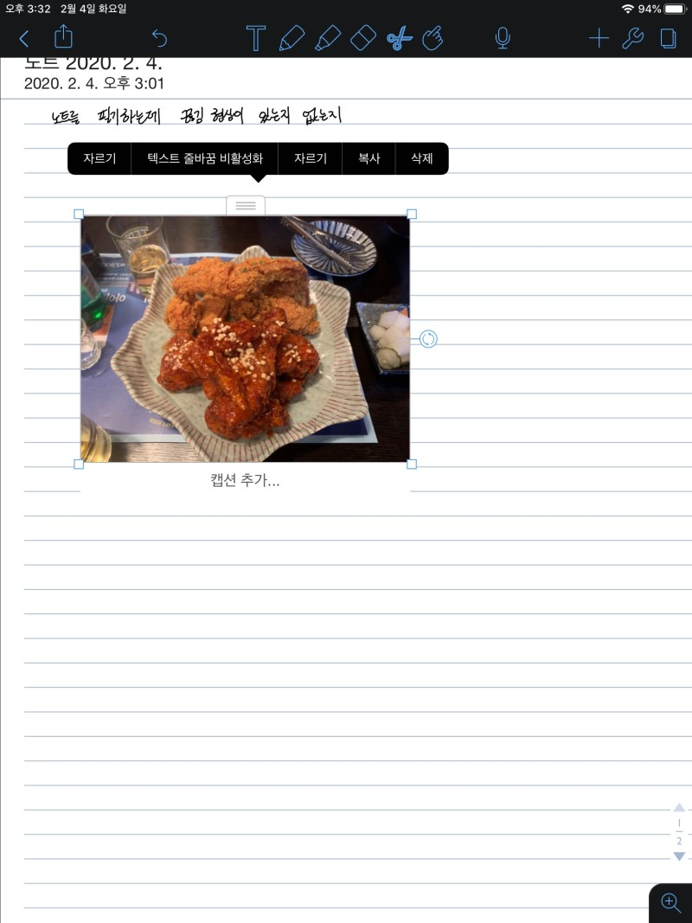
<picture of attaching picture on ‘Notability’>
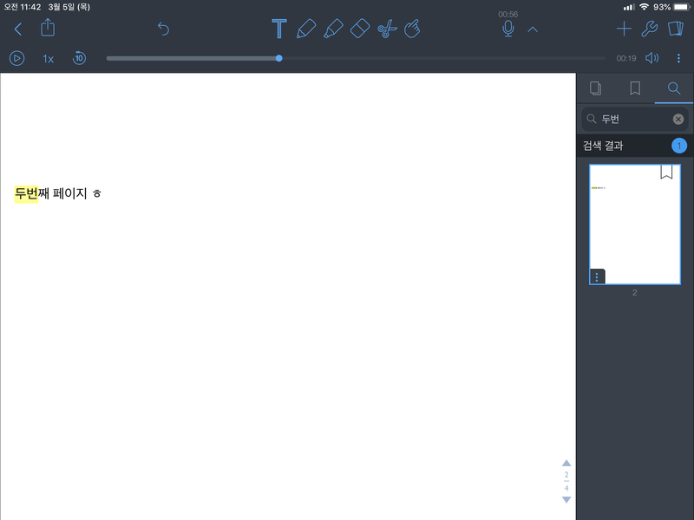
<picture of texting on ‘Notability’>

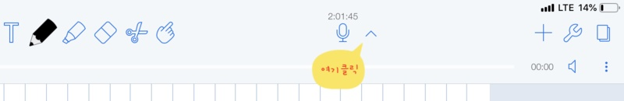
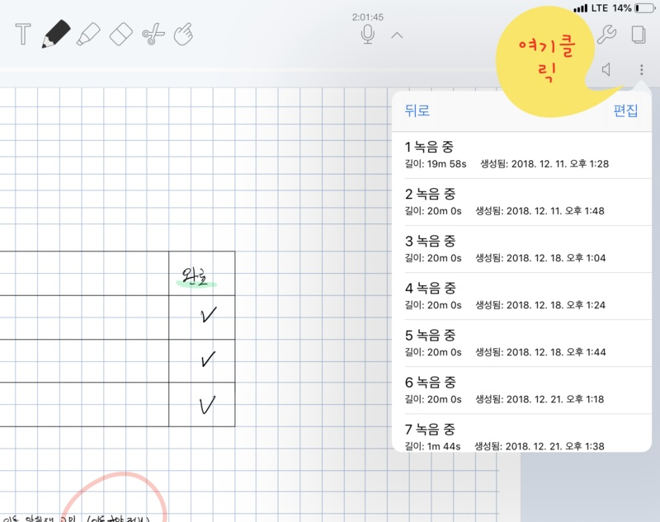
<picture of voice recording on ‘GoodNote’>
Voice recording feature will be useful to students who want to review the lesson

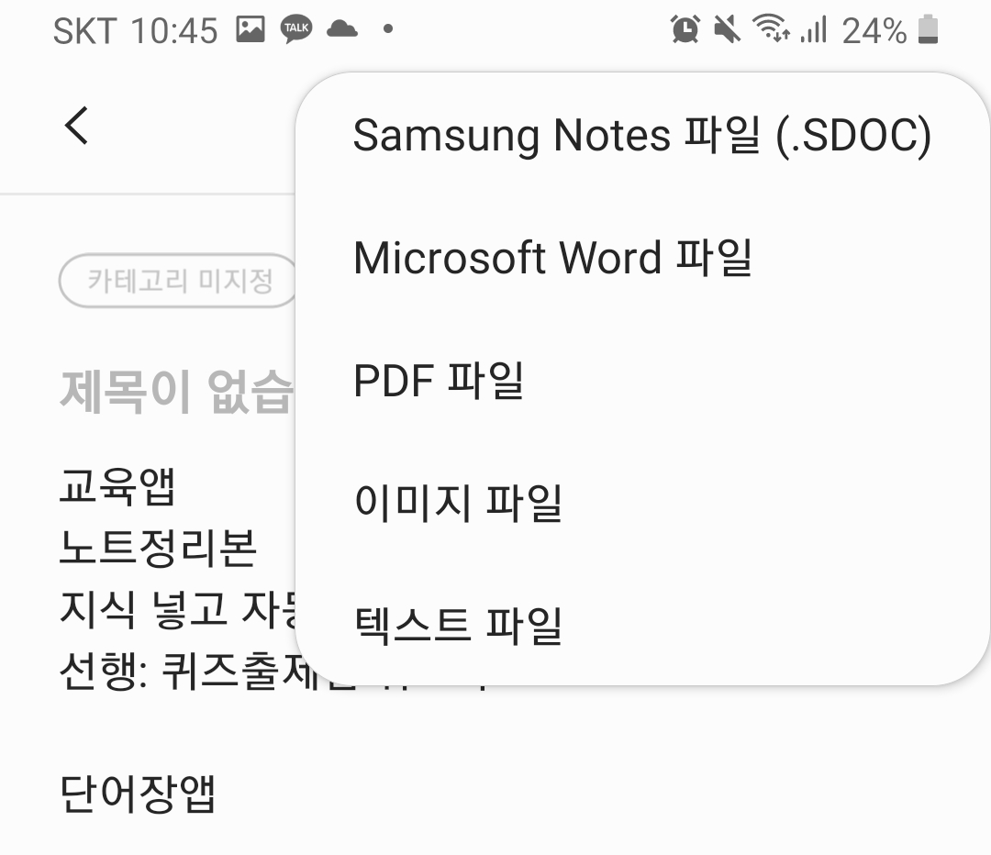
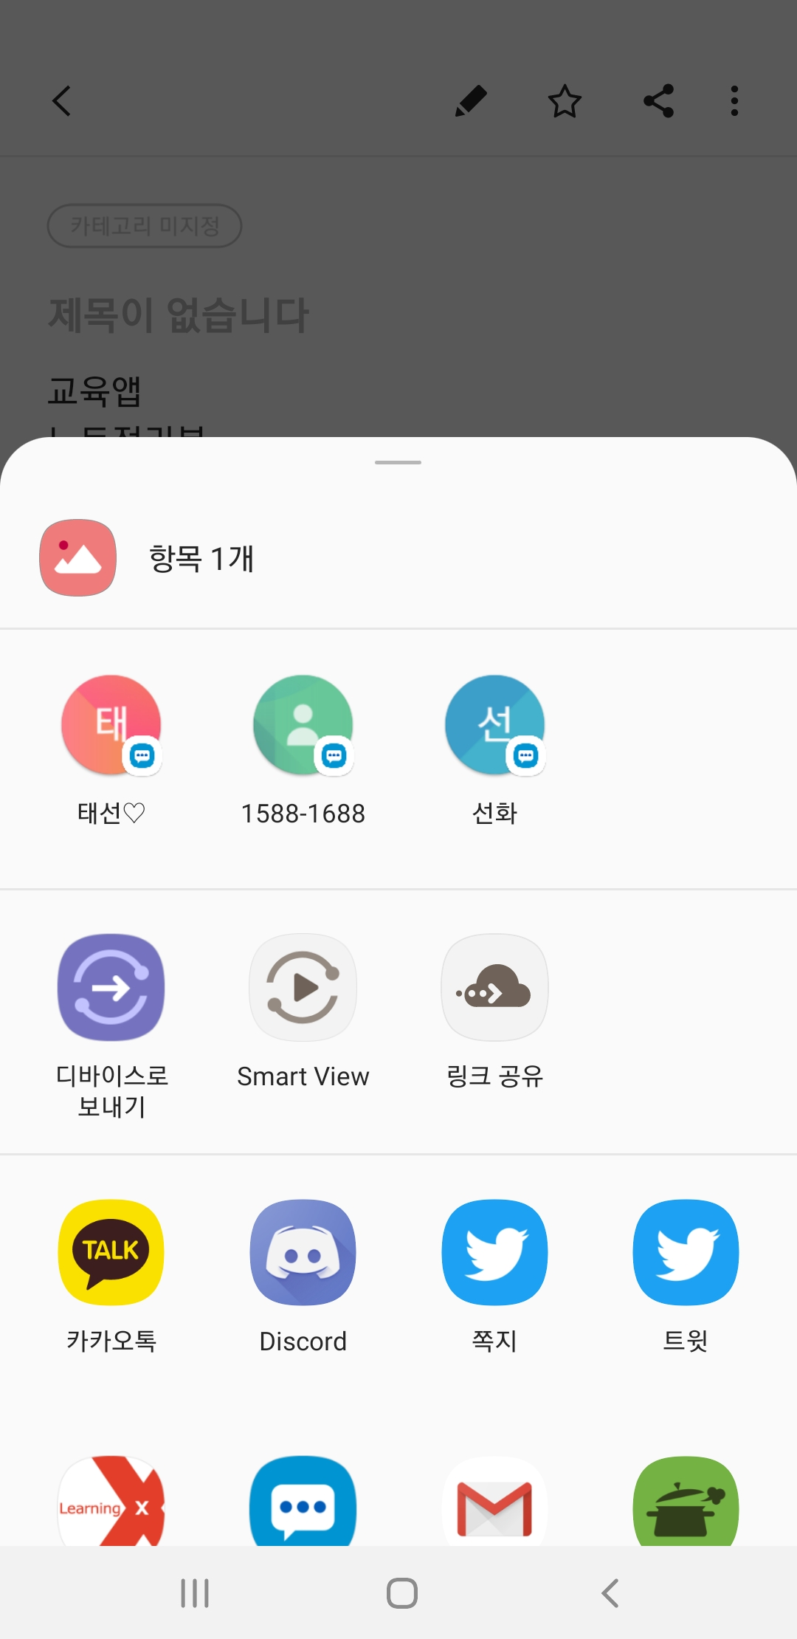
<picture of sharing notes to other people>

We are planning to add this sharing feature on our Note application. Note will be shared with the user’s permission.

